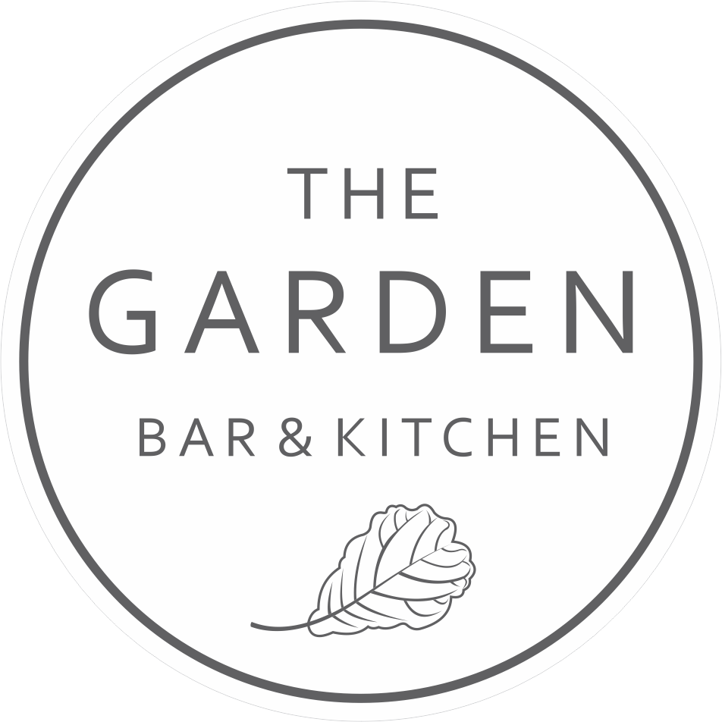

D E S S E R T

MANGO CHEESECAKE 16 GFO
coconut gelato | mango puree | lime crumble

THE COOKIE 14
macadamia & walnuts | valrhona chocolate | hokey pokey ice cream

BROWNIE 15
warm chocolate brownie | raspberry espuma | pistachio ice cream | hundreds & thousands

THE GARDENER’S COFFEE. 12
our signature blend of kahlua, frangelico,
baileys in a long black

AFFOGATO 10
+ liquors 7

SALTED CARAMEL ESPRESSO MARTINI 22
caramel liqueur | baileys | vodka | espresso

DESSERT WINE 12/56
2016 Woodstock Botrytis Semillon, McLaren Vale, SA

